EXIT TICKETS – 3.1.2 j,k,l – Classification Processes: Ecosystems – ANSWERS

**1.**

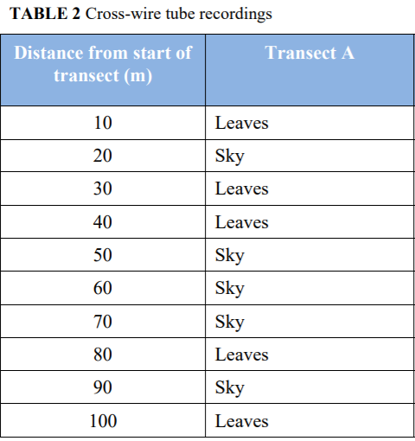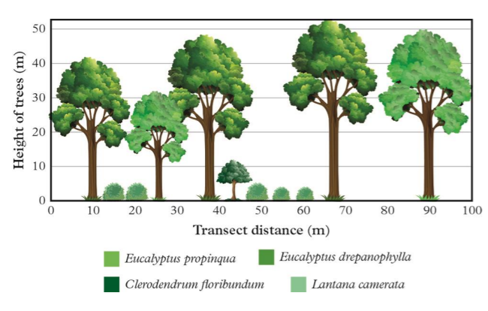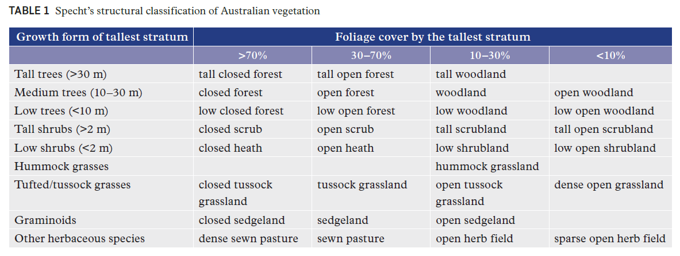k. Interpret data to classify and name an ecosystem

In order to look at factors that could influence biodiversity a 100 m x 5 m transect survey was conducted through vegetation typical of South East Queensland. The dominant tall stratum species were *Eucalyptus propinqua* and *E. drepanophylla*. Two measures were made of the percentage of foliage cover – one by measuring the diameter of the canopy (as plotted on the tree diagram) and the other by using a cross-wire tube and recording the number of foliage sites of the tallest strata of trees (>30m) as a percentage of the total number of observation sites.

1. Determine the percentage of foliage cover using both methods. (2 marks)

A - Diameter of canopy – 85%

B - Cross-wire – 50%

1. Using Specht’s classification system and one of the two given methods (slide 22) classify the vegetation in the given transect. **(1 mark)**

A - Diameter of canopy – Tall closed forest

B - Cross-wire – Tall open forest

**2.**

**l. Explain** how the process of classifying ecosystems is an important step towards effective ecosystem management (consider old-growth forests, productive soils and coral reefs)

**PUBLIC ACCESS MOCKEXAM (2020) SA 2**

**QUESTION 2 (4 marks)**

Explain how the process of classifying ecosystems is an important step toward effective ecosystem management of an old-growth forest.

The classification of forest as old growth, based on specific characteristics of the vegetation community, enables environmental managers to make specific strategic decisions relevant to that ecosystem.

More specifically, It results in a range of stakeholders (people to whom the forest is important) being able to make decisions relevant to a range of values (things that they want from the forest).

Additionally, It results in managers having the ability to identify effective and tailored management activities, such as proscribed burns.

It results in a deeper understanding of human impacts. This helps to improve the long term resilience of this delicate and significant ecosystem as these impacts can be reduced.